 Answers to review questions from Chapter 17
1. True or false: The elements of a set are unordered, so the set {3, 2, 1} and the set {1, 2, 3} represent the same set.

True.

2. True or false: A set can contain multiple copies of the same element.

False.

3. What sets are denoted by each of the following symbols: ∅, Z, N, and R?

∅ The empty set
Z The set of integers
N The set of natural numbers, which consists of the nonnegative integers
R The set of real numbers

4. What do the symbols ∈ and ∉ mean?

The conditional tests element of and not element of.

5. Use an enumeration to specify the elements of the following set:

{x | x ∈ N and x ≤ 100 and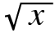 ∈ N}

{0, 4, 9, 25, 36, 49, 64, 81, 100}

6. Write a rule-based definition for the following set:

{0, 9, 18, 27, 36, 45, 54, 63, 72, 81}

{x | x ∈ N and x ≤ 100 and x is divisible by 9}

7. What are the mathematical symbols for the operations union, intersection, and set difference?

Union: ∪
Intersection: ∩
Set difference: –

8. Evaluate the following set expressions:

a. {a, b, c} ∪ {a, c, e} { a, b, c, e }
b. {a, b, c} ∩ {a, c, e} { a, c }
c. {a, b, c} – {a, c, e} { b }
d. ({a, b, c} – {a, c, e}) ∪ ({a, b, c} – {a, c, e}) { b }

9. What is the difference between a subset and a proper subset?

A proper subset is a subset that is not equal to the original set.

10. Give an example of an infinite set that is a proper subset of some other infinite set.

{x | x ∈ N and x is odd} is a proper subset of N

11. For each of the following set operations, draw Venn diagrams whose shaded regions illustrate the contents of the specified set expression:

a. A ∪ (B ∩ C)  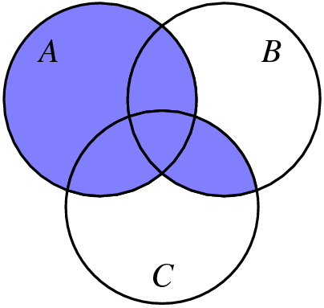 | c. (A – B) ∪ (B – A)  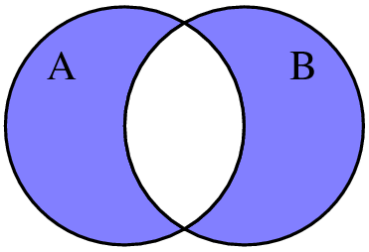
b. (A – C) ∩ (B – C)  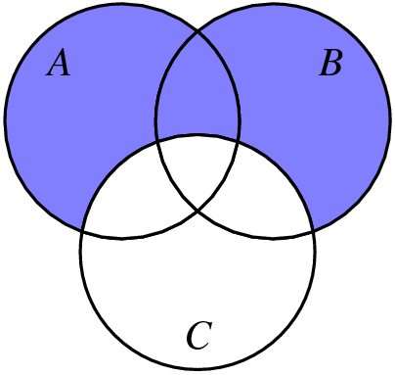 | d. (A ∪ B) – (A ∩ B)  

12. Write set expressions that describe the shaded region in each of the following Venn diagrams:

a. | 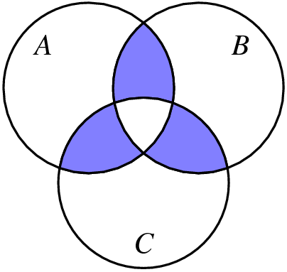 |  | b. | 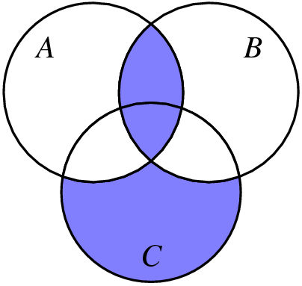
((A ∩ B) – C) ∪ ((A ∩ C) – B) ∪ ((B ∩ C) – A) |  | (A ∩ B) ∪ (C – (A ∪ B))

13. Draw Venn diagrams illustrating each of the identities in Table 17-1.

Idempotence
S | S ∩ S | S ∪ S
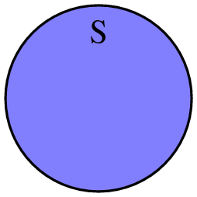 |  | 

Absorption
A ∩ (A ∪ B) | A ∪ (A ∩ B) | A
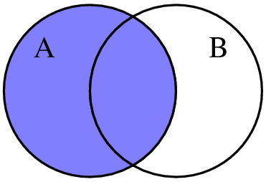 |  | 

Commutative laws
A ∪ B | B ∪ A | A ∩ B | B ∩ A
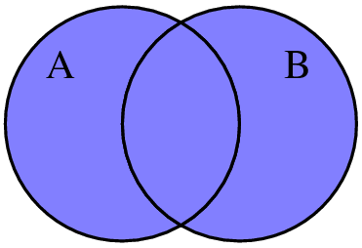 |  | 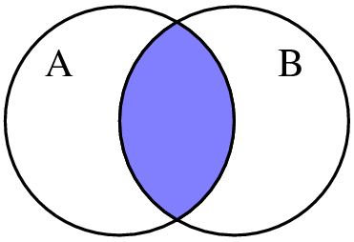 | 

Associative laws
A ∪ (B ∪ C) | (A ∪ B) ∪ C | A ∩ (B ∩ C) | (A ∩ B) ∩ C
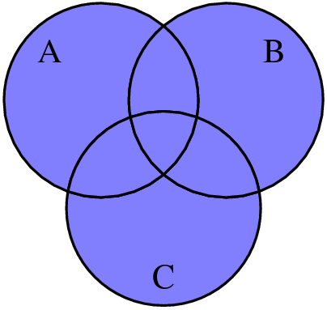 |  | 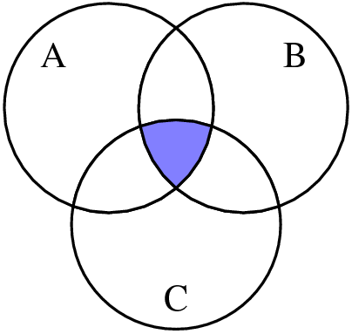 | 

Distributive laws
A ∪ (B ∩ C) | (A ∪ B) | (A ∪ C) | (A ∪ B) ∩ (A ∪ C)
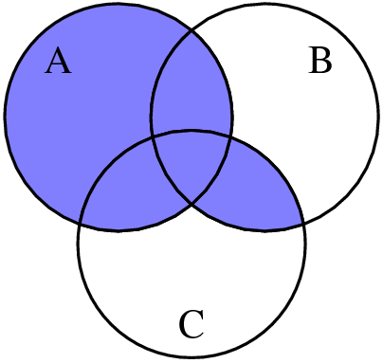 | 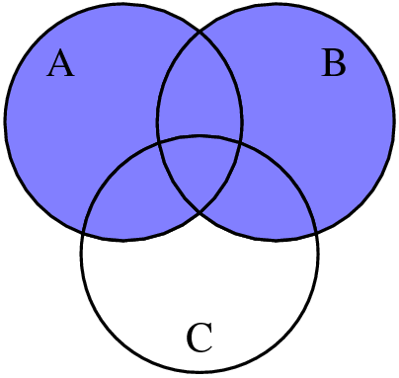 |  | 
A ∩ (B ∪ C) | (A ∩ B) | (A ∩ C) | (A ∩ B) ∪ (A ∩ C)
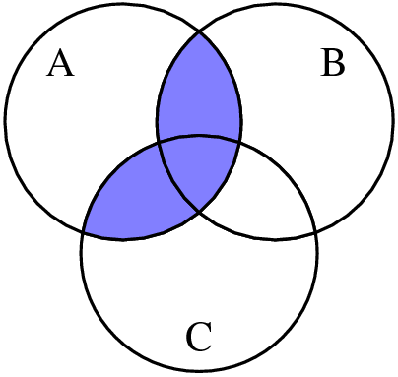 | 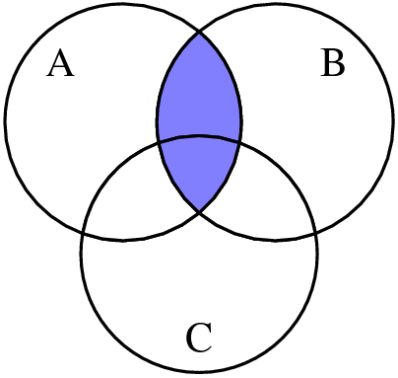 | 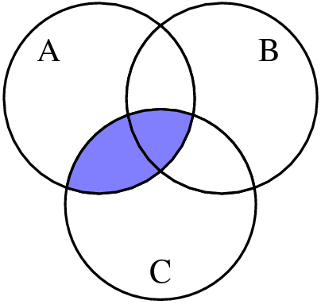 | 

Second De Morgan’s law (the first is in the text)
A – (B ∪ C) | (A – B) | (A – C) | (A – B) ∩ (A – C)
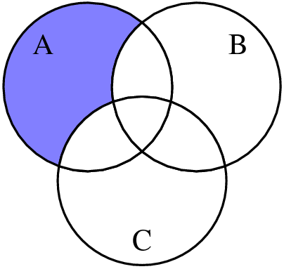 | 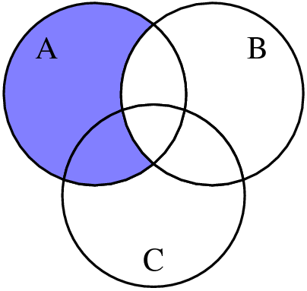 | 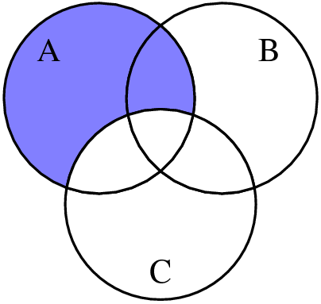 | 

14. What is the cardinality of a set?

The cardinality of a set is the number of elements it contains.

15. The general implementation of the Set class uses a data structure from an earlier chapter to represent the elements of a set. What is that structure? What properties make that structure useful for this purpose?

The set implementation uses a map for its implementation because doing so provides efficient insertion, removal, and searching for keys.

16. What is a characteristic vector?

A characteristic vector is an array of bits in which each bit corresponds to the presence or absence of the corresponding index element in a set.

17. What restrictions must be placed on a set in order to use characteristic vectors as an implementation strategy?

The number of possible elements must be small enough to allow the entire characteristic vector to fit in a reasonable amount of memory.

18. Assuming that RANGE_SIZE has the value 10, diagram the characteristic vector for the set {1, 4, 9}.

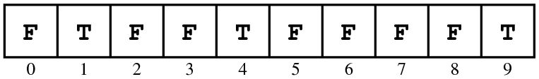

19. What set is represented by the following characteristic vector:

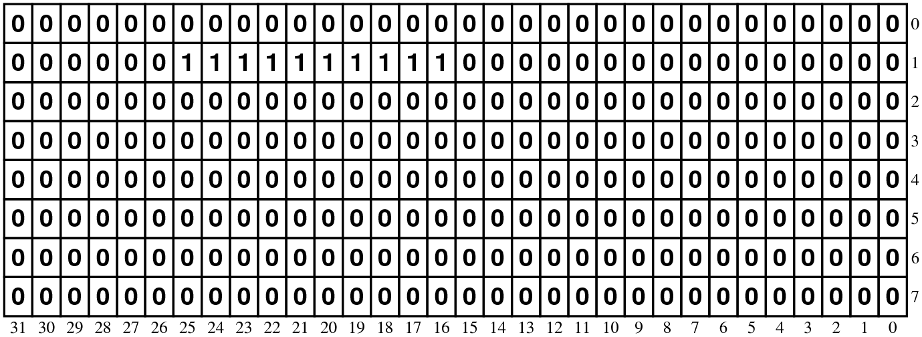

By consulting the ASCII chart in Table 1-2, identify the function in <cctype> to which this set corresponds.

This set contains the ASCII codes for the digit characters and therefore implements isdigit.

20. In the diagrams used to represent characteristic vectors, an unsigned long is shown as taking 32 bits. Suppose that you have a machine on which a long takes 64 bits instead. Does the code given in the chapter continue to work?

Yes. The code uses the sizeof operator to determine the size of an unsigned long and then adjusts the array sizes accordingly.

21. Suppose that the variables x and y are of type unsigned short and contain the following bit patterns:

Expressing your answer as a sequence of bits, compute the value of each of the following expressions:

a. x & y  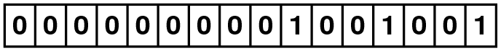 | f. x & ~y  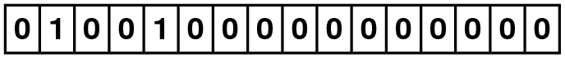
b. x | y  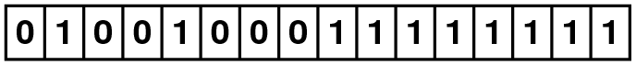 | g. ~x & ~y  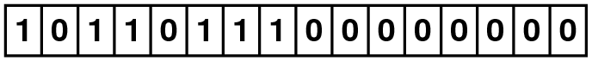
c. x ^ y  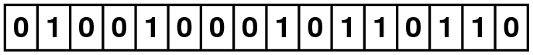 | h. y >> 4  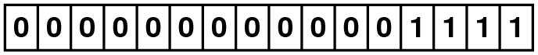
d. x ^ x  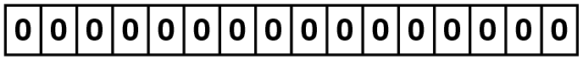 | i. x << 3  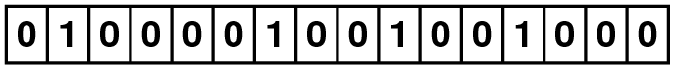
e. ~x  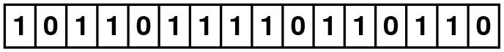 | j. (x >> 8) & y  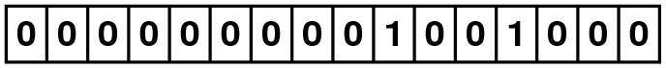

22. Express the values of x and y from the preceding exercise as constants using both octal and hexadecimal notation.

x = 44111₈ = 4849₁₆
y = 377₈ = FF₁₆

23. Suppose that the variables x and mask are both declared to be of type unsigned, and that the value of mask contains a single 1 bit in some position. What expressions would you use to implement the following operations:

a. Test the bit in x corresponding to the bit in mask to see if it is nonzero.
if ((x & mask) != 0)

b. Set the bit in x corresponding to the bit in mask.
x |= mask;

c. Clear the bit in x corresponding to the bit in mask.
x &= ~mask;

d. Complement the bit in x corresponding to the bit in mask.
x ^= mask;

24. Write an expression that constructs a mask of type unsigned in which there is a single 1 bit in bit position k, where bits are numbered from 0 starting at the right end of the word. For example, if k is 2, the expression should generate the following mask:

((unsigned) 1) << k

